Phase 3: Project Design Phase

The structure of the system is designed. Data models, user interfaces, and workflows are planned. For example, how restaurants can log leftover food, how NGOs can request food, and how notifications will be managed. Wireframes or mockups are created to visualize the system before development begins.

Milestone 4: THE LIGHTNING APP:-

Create a Lightning App:

To create a lightning app page

- Go to setup page >> search “app manager” in quick find >> select “app manager” >> click on New lightning App.
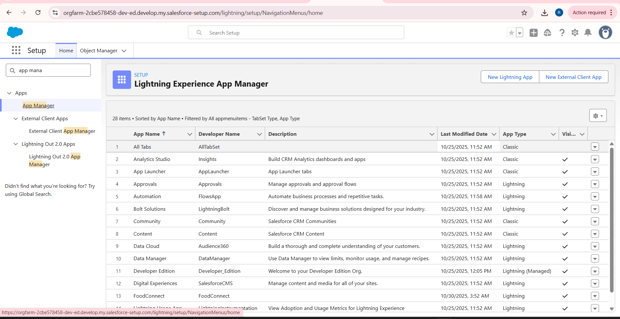

- Fill the app name in app details and branding as follow

  - App Name : FoodConnect
  - Developer Name : This will auto populated
  - Image : optional (if you want to give any image you can otherwise not mandatory)
  - Primary color hex value : keep this default.

- Then click Next >> (App option page)Set Navigation Style as Standard Navigation >> Next.

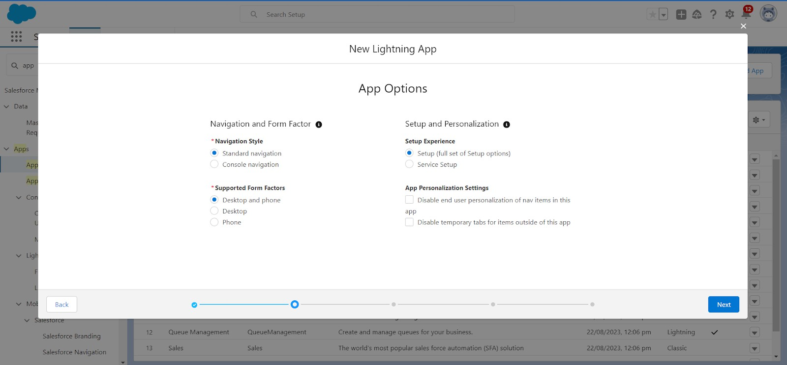
- (Utility Items) keep it as default >> Next.

- To Add Navigation Items:

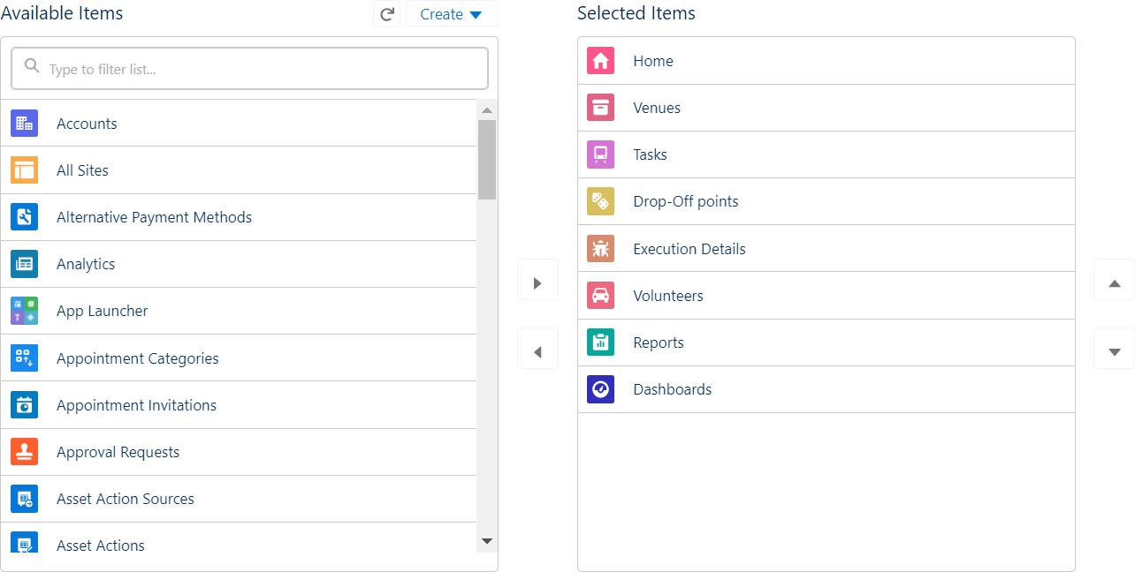
Search for the item in the (Home, Venue, Drop-Off Point, Task, Volunteer, Execution Details, Reports) from the search bar and move it using the arrow button
>> Next >> Next.

G. To Add User Profiles:
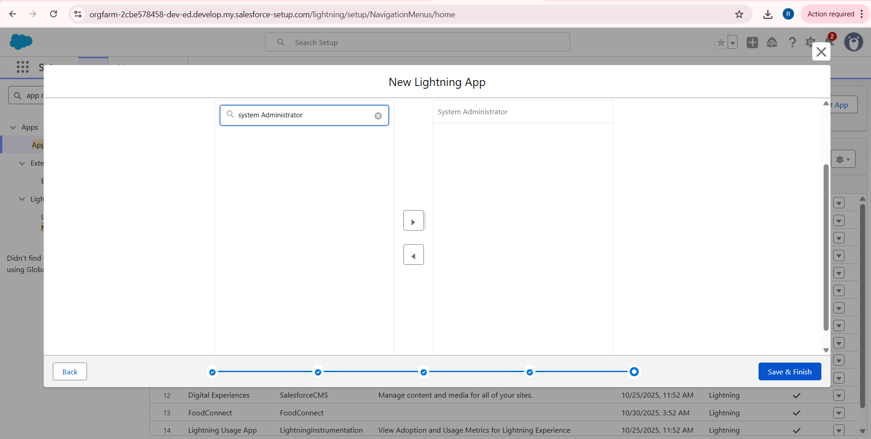

Search profiles (System administrator) in the search bar >> click on the arrow button
>> save & finish.

Milestone 5: FIELDS :-

Activity 1: Creation of Relationship Fields in Object:-

Creation of Lookup Relationship Field on Volunteer Object:

- Go to setup >> click on Object Manager >> type object name(Volunteer) in the search bar >> click on the object.
- Now click on “Fields & Relationships” >> New
- Select Master Detail relationship

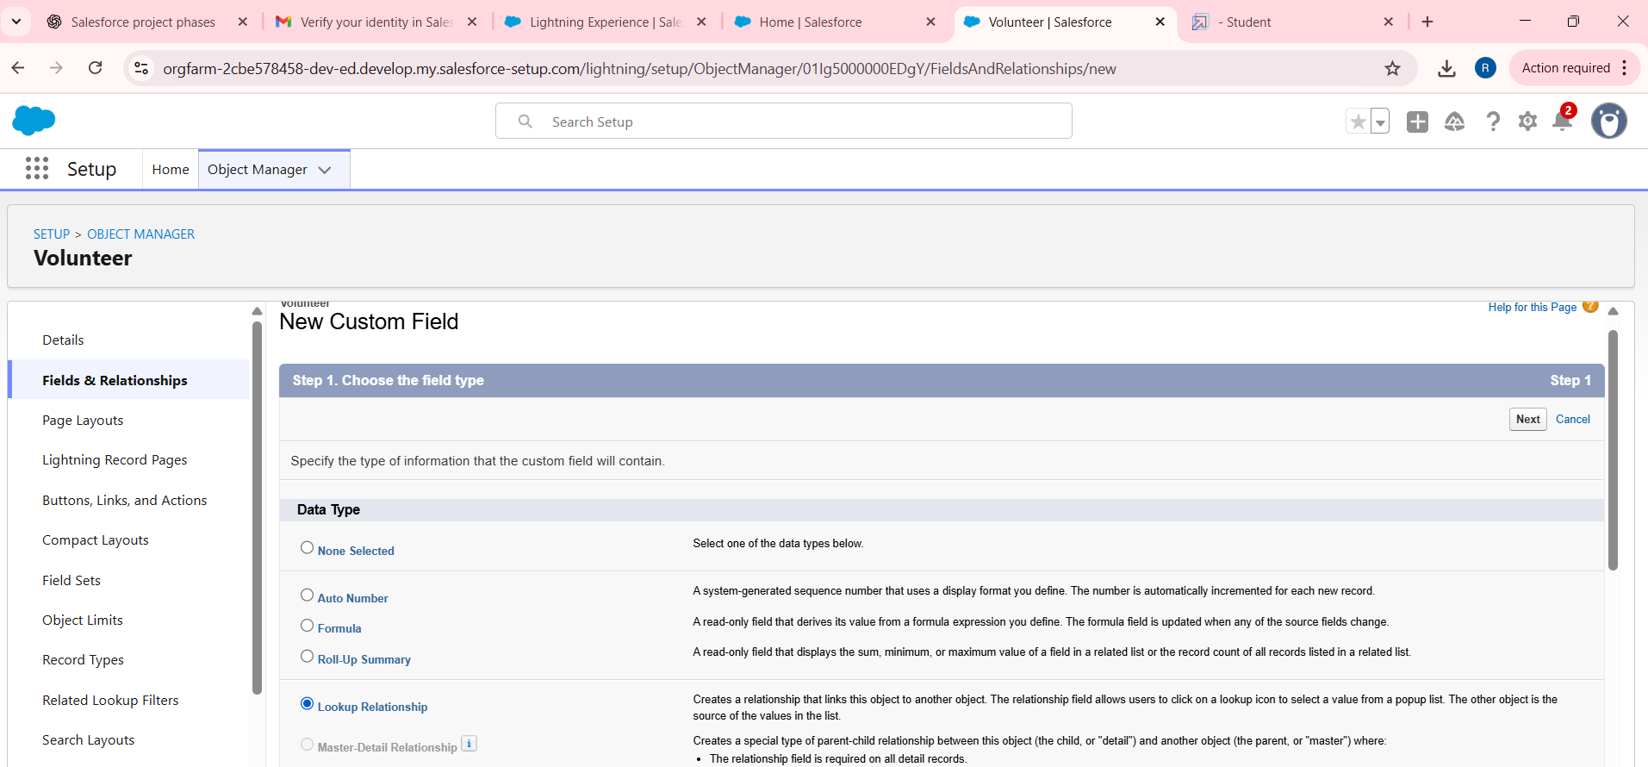

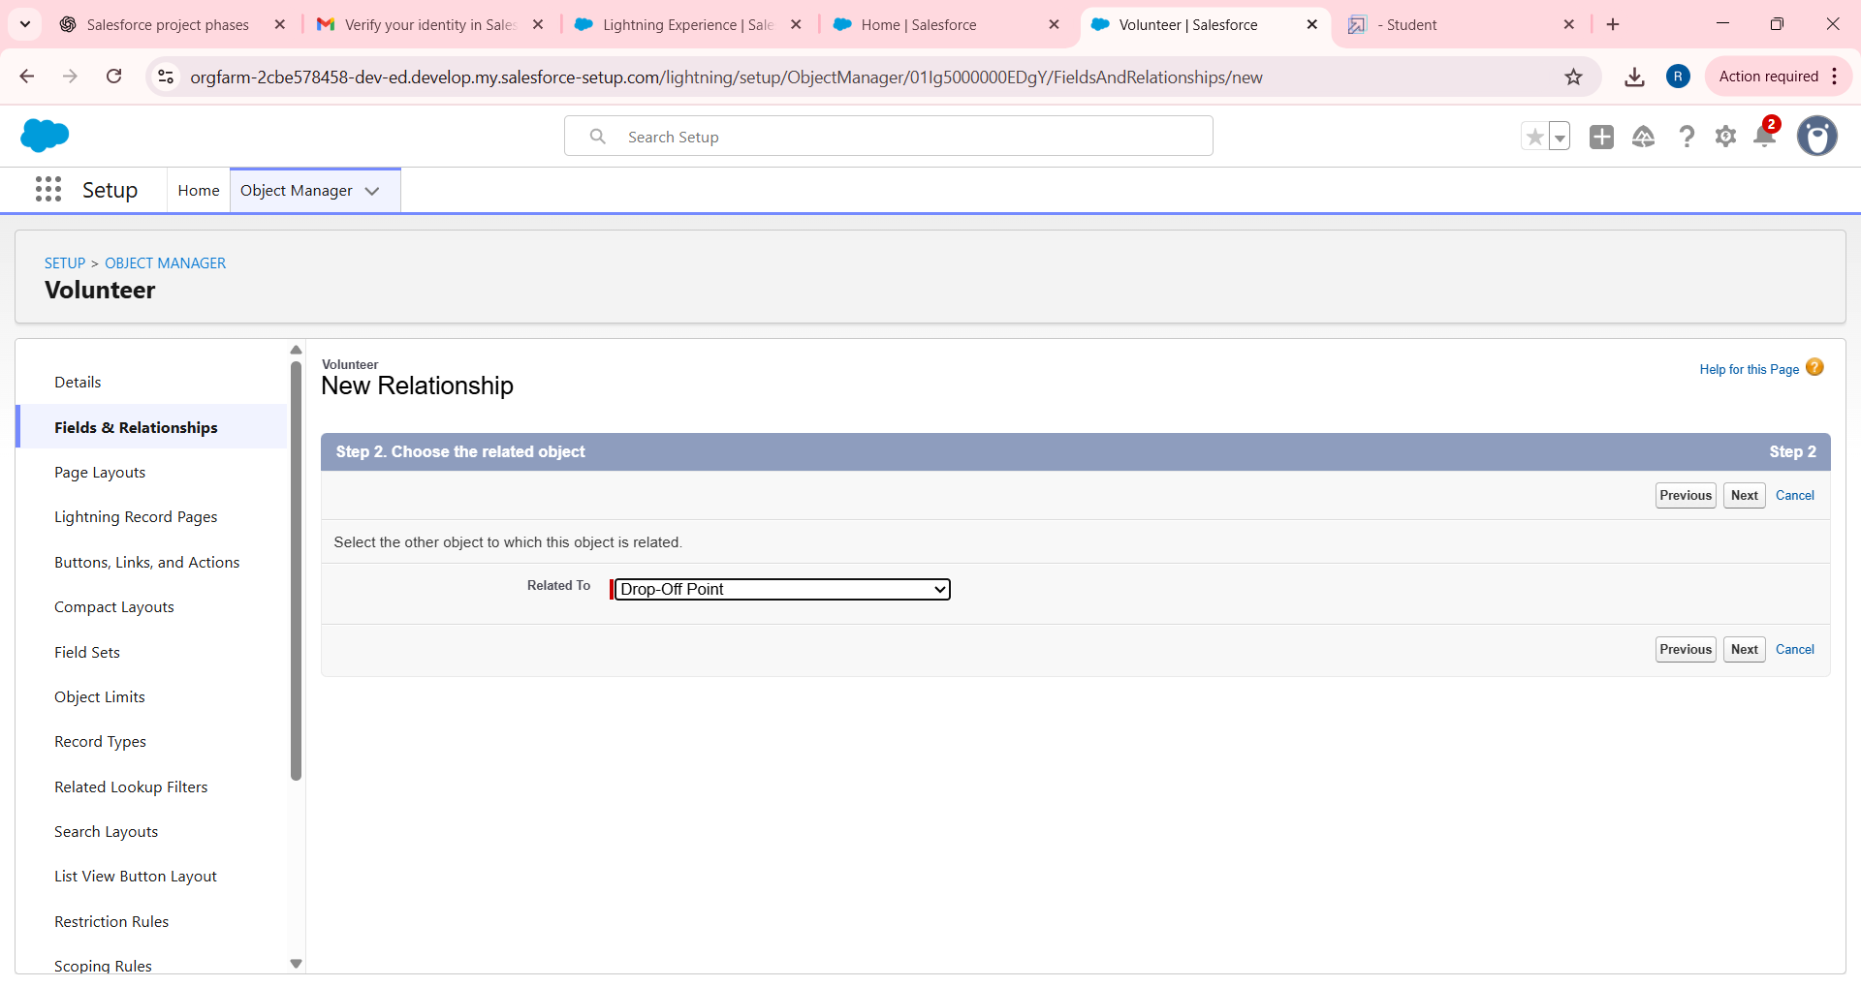

- Select the related object “Drop-Off point” and click next.
- Field Name : Drop_Off_point
G. Field label : Auto generated
- Next >> Next >> Save.

Creation of Master-Detail Relationship Field on Execution Detail Object:

- Go to setup >> click on Object Manager >> type object name(Execution Details) in the search bar >> click on the object.
- Now click on “Fields & Relationships” >> New
- Select Master Detail relationship
- Select the related object “Volunteer” and click next.
- Field Name : Volunteer
- Field label : Auto generated
- Next >> Next >> Save.

Creation of Master-Detail Relationship Field on Execution Detail Object:

- Go to setup >> click on Object Manager >> type object name(Execution Details) in the search bar >> click on the object.
16. Now click on “Fields & Relationships” >> New
- Select Master Detail relationship
- Field Name : Task
- Field label : Auto generated
- Next >> Next >> Save.

Creation of Look-Up Relationship Field on Drop-off Point Object:

- Go to setup >> click on Object Manager >> type object name(Drop-Off Point) in the search bar >> click on the object.
- Now click on “Fields & Relationships” >> New
- Select Lookup relationship
- Select the related object “Venue” and click next. 2G. Field Name : Venue
- Field label : Venue c
- Next >> Next >> Save.

Creation of Lookup Relationship Field on Task Object:

- Go to setup>> click on Object Manager >> type object name(Task) in the search bar >> click on the object.
- Now click on “Fields & Relationships” >> New
- Select Lookup relationship
- Select the related object “Venue” and click next.
- Field Name : Sponsored By
- Field label : Auto generated
- Next >> Next >> Save.

Creation of Lookup Relationship Field on Task Object:

3G. Go to setup>> click on Object Manager >> type object name(Task) in the search bar >> click on the object.
- Now click on “Fields & Relationships” >> New
- Select Lookup relationship
- Select the related object “Drop-Off point” and click next.
- Field Name : Drop-Off point
- Field label : Auto generated
- Next >> Next >> Save.

Activity 2: Creation of Fields for Venue Object:-

- Go to setup>> click on Object Manager >> type object name(Venue) in search bar >> click on the object.
- Now click on “Fields & Relationships” >> New
- Select Data type as a “Email” and Click on Next
- Fill the Above as following:
  - Field Label : Contact Email
  - Field Name : Contact Email
  - Click on required check box
  - Click on Next >> Next >> Save and new.

To create another fields in an object:
- Go to setup >> click on Object Manager >> type object name(Venue) in search bar >> click on the object.
G. Now click on “Fields & Relationships” >> New
- Select Data type as a “Phone” and Click on Next
- Fill the Above as following:
  - Field Label : Contact Phone
  - Field Name : Contact Phone
  - Click on required check box
  - Click on Next >> Next >> Save and new.
- Select Data type as a “Geolocation” and Click on Next
- Fill the Above as following:
  - Field Label : Location
  - Decimal Places : 4
  - Field Name : Location

  - Description : Enter the Geolocation of your Venue
  - Click on Next >> Next >> Save and new.
- Select Data type as a “Long Text Area” and Click on Next
- Fill the Above as following:
  - Field Label : Venue Location
  - Field Name : Venue_Location
  - Click on Next >> Next >> Save and new.

Activity 3: Creation of Fields for Drop-Off Point Object:-

- Go to setup >> click on Object Manager >> type object name(Drop-Off point) in search bar >> click on the object.
- Now click on “Fields & Relationships” >> New
- Select Data type as a “Geolocation” and Click on Next
- Fill the Above as following:
  - Field Label : Location 2
  - Field Name : Gets auto generated.
  - Description : Enter the Geolocation of the Drop off Point
  - Geolocation Options : select Decimal
  - Decimal Places : 4
  - Click on Next >> Next >> Save and new.

To create another fields in an object:
- Go to setup >> click on Object Manager >> type object name(Drop-Off point) in search bar >> click on the object.
- Now click on “Fields & Relationships” >> New
- Select Data type as a “Formula” and Click on Next
- Fill the Above as following:
  - Field Label : distance calculation
  - Field Name : distance_calculation
  - Formula Return Type : Number
  - Formula Options :
  - Click on Next >> Next >> Save and new.

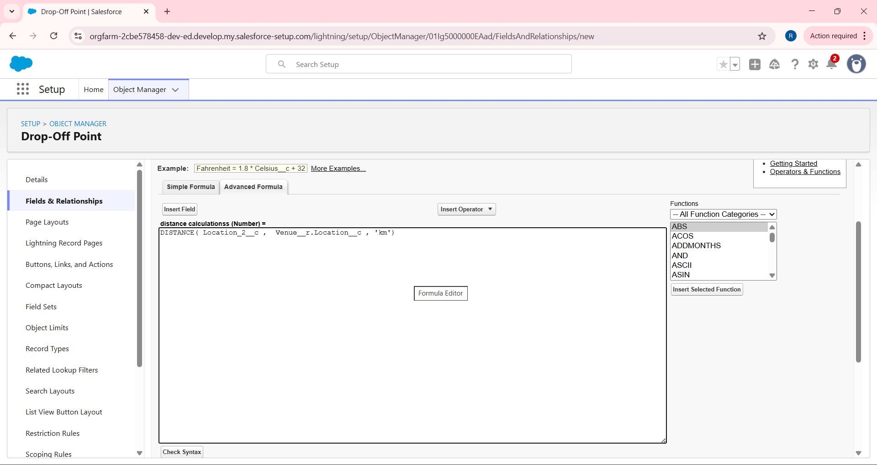
- Select Data type as a “Picklist” and Click on Next
G. Fill the Above as following:
- Field Label : State
- Field Name : State
- Enter values, with each value separated by a new line : Andhra Pradesh
Arunachal Pradesh Assam
Bihar Chhattisgarh Goa
Gujarat Haryana
Himachal Pradesh Jharkhand Karnataka
Kerala Maharashtra Madhya Pradesh Manipur

Meghalaya Mizoram Nagaland Odisha Punjab Rajasthan Sikkim Tamil Nadu Tripura Telangana
Uttar Pradesh Uttarakhand West Bengal
Andaman & Nicobar (UT) Chandigarh (UT)
Dadra & Nagar Haveli and Daman & Diu (UT) Delhi [National Capital Territory (NCT)] Jammu & Kashmir (UT)
Ladakh (UT) Lakshadweep (UT) Puducherry (UT)
- Click on required check box
- Click on Next >> Next >> Save and new.
- Select Data type as a “Number” and Click on Next
- Fill the Above as following:
  - Field Label : Distance
  - Field Name : Distance
  - Length : 14
  - Decimal Places : 4
  - Click on required check box

  - Click on Next >> Next >> Save and new.

Activity 4: Creation of Fields for Task Object:-

- Go to setup>> click on Object Manager >> type object name(Task) in search bar
>> click on the object.
- Now click on “Fields & Relationships” >> New
- Select Data type as a “Auto Number” and Click on Next
- Fill the Above as following:
  - Field Label : Task ID
  - Display Format : TASK-{0}
  - Starting Number : 1
  - Field Name : gets auto generated
  - Click on required check box
  - Click on Next >> Next >> Save and new.

To create another fields in an object:
- Go to setup >> click on Object Manager >> type object name(Task) in search bar
>> click on the object.
- Now click on “Fields & Relationships” >> New
- Select Data type as a “Date” and Click on Next
- Fill the Above as following:
  - Field Label : Date
  - Field Name : Date
  - Click on required check box
  - Click on Next >> Next >> Save and new.
- Select Data type as a “Picklist (Multi-Select)” and Click on Next
G. Fill the Above as following:
- Field Label : Food Category
- Field Name : Food Category
- Enter values, with each value separated by a new line :

Veg Non-Veg Salad Snack
- Click on required check box
- Click on Next >> Next >> Save and new.
- Select Data type as a “Number” and Click on Next
- Fill the Above as following:
  - Field Label : Number of People Served
  - Field Name : Number_of_People_Served
  - Click on required check box
  - Click on Next >> Next >> Save and new.
- Select Data type as a “Text” and Click on Next
- Fill the Above as following:
  - Field Label : Name of the Person
  - Field Name : Name_of_the_Person
  - Click on Next >> Next >> Save and new.
- Select Data type as a “Phone” and Click on Next
- Fill the Above as following:
  - Field Label : Phone
  - Field Name : Phone
  - Click on Next >> Next>> Save and new.
- Select Data type as a “Pick List” and Click on Next
- Fill the Above as following:
  - Field Label : Rating
  - Field Name : Rating
  - Enter values, with each value separated by a new line :
1
2
3
4
5

  - Click on Next >> Next >> Save and new.
- Select Data type as a “Long Text Area” and Click on Next 1G. Fill the Above as following:
  - Field Label : Feedback
  - Field Name : Feedback
  - Click on Next >> Next >> Save and new.

Activity 5: Creation of Fields for the Volunteer Object:-

- Go to setup >> click on Object Manager >> type object name(Volunteer) in search bar >> click on the object.
- Now click on “Fields & Relationships” >> New
- Select Data type as a “Auto Number” and Click on Next
- Fill the Above as following:
  - Field Label : Volunteer ID
  - Field Name : gets auto generated
  - Click on required check box
  - Click on Next >> Next >> Save and new.

To create another fields in an object:
- Go to setup >> click on Object Manager >> type object name(Volunteer) in search bar >> click on the object.
- Now click on “Fields & Relationships” >> New
- Select Data type as a “Picklist” and Click on Next
- Fill the Above as following:
  - Field Label : Gender
  - Field Name : Gender
  - Enter values, with each value separated by a new line : Female
Male
  - Click on Next >> Next >> Save and new.

- Select Data type as a “Date” and Click on Next
G. Fill the Above as following:
- Field Label : Available On
- Field Name : Available On
- Click on required check box
- Click on Next >> Next >> Save and new.
- Select Data type as a “Number” and Click on Next
- Fill the Above as following:
  - Field Label : Age
  - Field Name : Age
  - Click on required check box
  - Click on Next >> Next>> Save and new.
- Select Data type as a “Email” and Click on Next
- Fill the Above as following:
  - Field Label : Email
  - Field Name : Email
  - Click on required check box
  - Click on Next>> Next >> Save and new.
- Select Data type as a “Number” and Click on Next
- Fill the Above as following:
  - Field Label : Contact Number
  - Field Name : Contact_Number
  - Click on required check box
  - Click on Next >> Next >> Save and new.
- Select Data type as a “Text Area (Long)” and Click on Next
- Fill the Above as following:
  - Field Label : Address
  - Field Name : Address
  - Click on Next >> Next >> Save and new.
- Select Data type as a “Date” and Click on Next 1G. Fill the Above as following:
  - Field Label : Date of Birth
  - Field Name : Date_of_Birth

  - Click on Next >> Next >> Save and new.

Activity 5: Creation of Fields for the Execution Details Object:-
- Go to setup >> click on Object Manager >> type object name(Volunteer) in search bar >> click on the object.
- Now click on “Fields & Relationships” >> New
- Select Data type as a “Auto Number” and Click on Next
- Fill the Above as following:
  - Field Label : Execution ID
  - Field Name : gets auto generated
  - Click on required check box
  - Click on Next >> Next >> Save and new.

Milestone 6: FLOWS :-

Create Flow to create a Record in Venue Object:

- Go to setup >> type Flow in quick find box >> Click on the Flow and Select the New Flow.
- Select the Screen flow. Click on create.
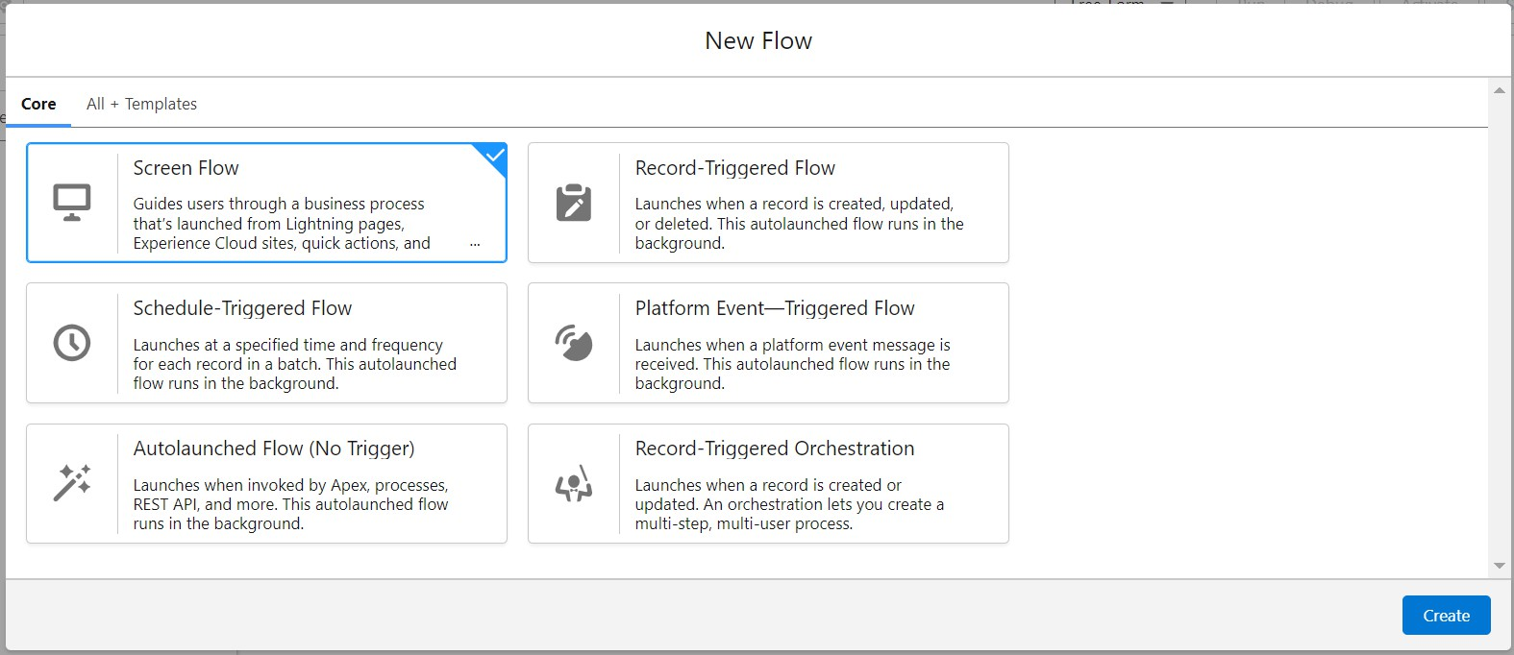

- Click on the ‘+’ icon in between start and end, and click on the screen element.
- Under the Screen Properties:
  - Label : Venue Details
  - API Name : Venue_Details
- Now let's add components in this flow. Click on Text Component and name it as:
  - Label : Venue Name
  - API Name : Venue_Name
G. Click on Email Component and name it as:
- Label : Email
- API Name : Contact_Email
- Click on Phone Component and name it as:
  - Label : Phone
  - API Name : Contact_Phone
- Click on Text Component and name it as:
  - Label : Venue Location
  - API Name : Venue_Location
- Click on Number Component and name it as:
  - Label : Latitude
  - API Name : Latitude
- Click on Number Component and name it as:
  - Label : longitude
  - API Name : longitude
- Next click on Done. This would like below
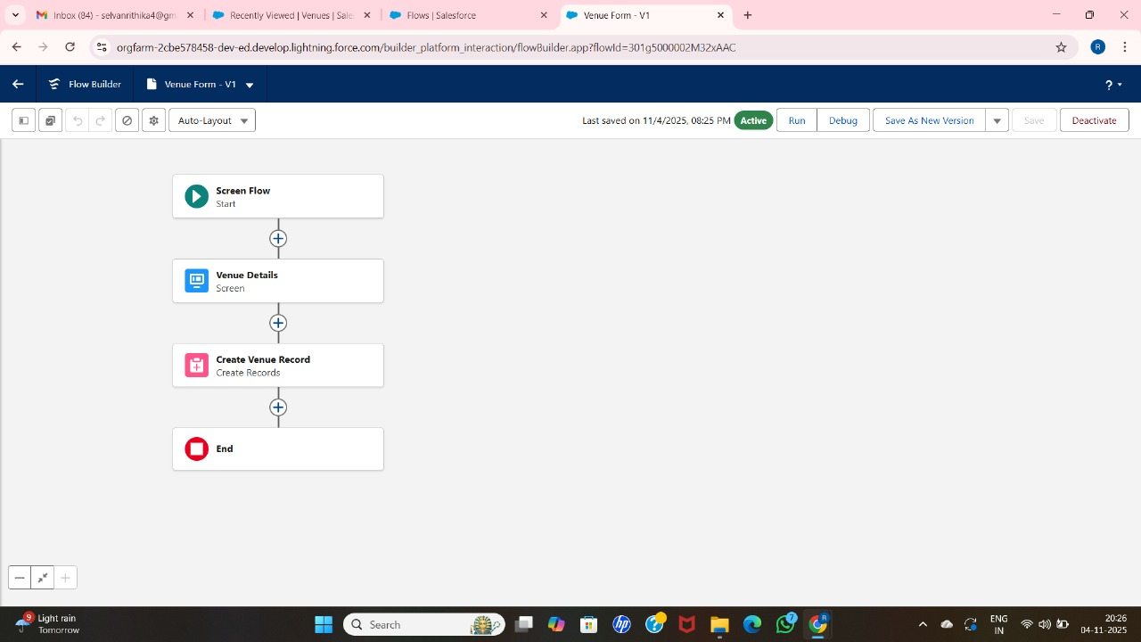

12 Click on the ‘+’ icon in between Venue details and end, and click on create record element.
- Now label it as
  - Label : Create Venue Record
  - API Name : Create_Venue_Record
  - How Many Records to Create : One
  - How to Set the Record Fields : Use separate resources, and literal values
  - Object : Venue

  - Set Field Values for the Venue : Click on ‘Add Field’ 5 times
  - Field : Value = Contact_Email c : {!Contact_Email.value}
  - Field : Value = Contact_Phone c : {!Contact_Phone.value}
  - Field : Value = Name : {!Venue_Name}
  - Field : Value = Venue_Location c : {!location}
  - Field : Value = Location Latitude s : {!latitude}
  - Field : Value = Location Longitude s : {!longitude}
- This would look like:
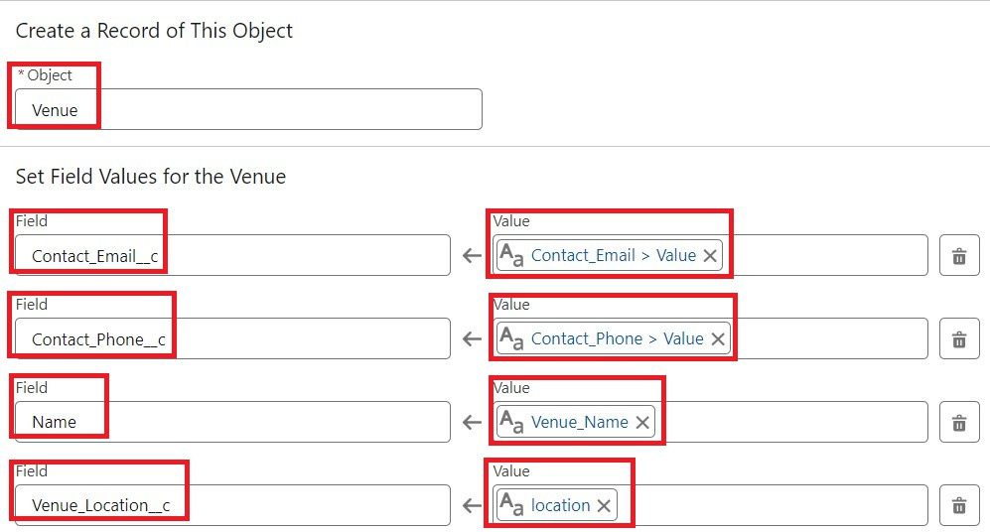
- Click on Save as:
Flow Label : Venue Form
Flow API Name : Venue_Form

Milestone 7: TRIGGER :-

Activity 1: Create a Trigger :
- Log into the trailhead account, navigate to the gear icon in the top right corner.
- Click on developer console and you will be navigated to a new console window.
- Click on the File menu in the toolbar, and click on new >> Trigger.
- Enter the trigger name and the object to be triggered.
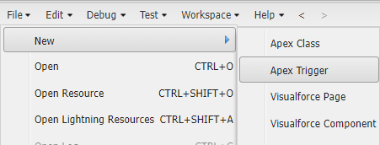

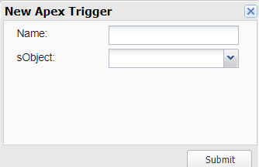

- Enter Name : DropOffTrigger sObject: Drop-Off Point c
G. Click on Submit.

Activity 2: Trigger Code :

(This Trigger is to assign the Distance field to the Distance Calculation field. So that we can assign the distance in the sharing rules.)

Code:
trigger DropOffTrigger on Drop_Off_point c (before insert) { for(Drop_Off_point c Drop : Trigger.new){
Drop.Distance c = Drop.distance c;
}

